Sample.txt:

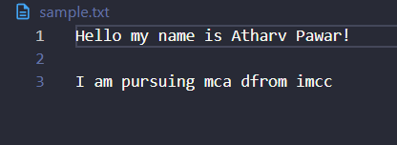
Q1. Write a program to read a file and count how many vowels are present in its content.

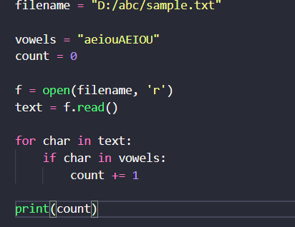

Output:

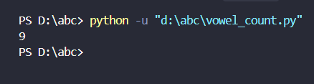

Q2. Read all the lines from a file into a list. Print the total number of lines and display the 2nd and 4th line
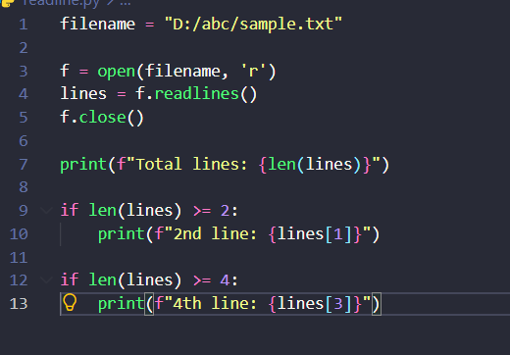
Output:
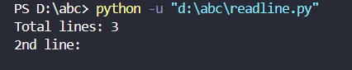

Q3. Take a sentence from the user, split it into words and store them in a list print the longest word.
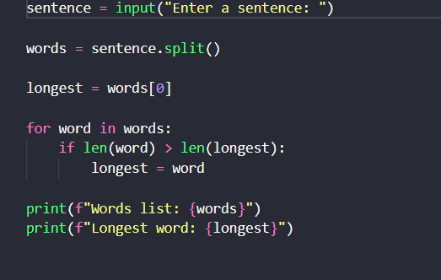
Output:
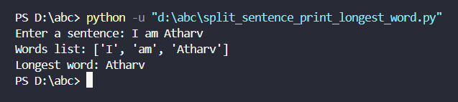
Q4. Read a file split its content into words and store them in a list.
i. int the total number of words

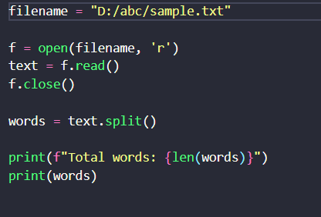
Output:
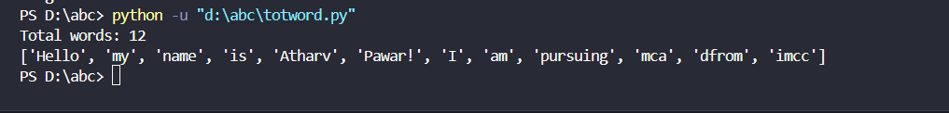

ii. Print all unique words

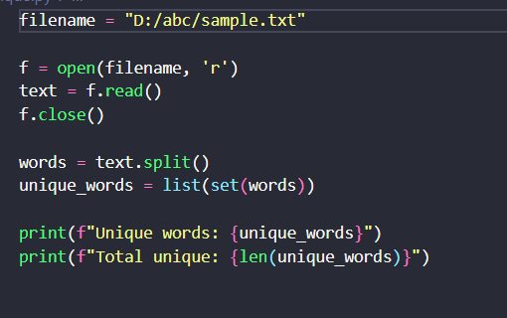
Output:
